Ever Green Sr. Sec. School


A Co-educational English Medium School
Sri Ganga Vihar Colony, Vill. Tularampur, Beriparao, P.O. Motahaldu, Lalkuan, Haldwani, Nainital (Uttarakhand)

INFORMATION TECHNOLOGY (402)
Name – Karan Bhatt
Class – 9th A
Topic – Deep Learning

Submitted to:
Mr. Praveen Joshi

Ever Green Sr. Sec. School


CERTIFICATE

This is to certify that I Karan Bhatt of class 9th A has successfully completed the project work on the topic Deep Learning under the guidance of my Information Technology teacher Mr, Praveen Joshi.

Thank you

Acknowledgement

Thanks to the Almighty, for giving me strength and ability to understand, learn and complete this report.
I would like to express my special thanks of gratitude to my computer teacher who gave me the golden opportunity to do this wonderful project on topic Deep Learning, which also helped me in doing a lot of research and I came to know about many new things I am thankful to them.
Secondly, I would also like to thank my parents and my sister who helped me in completing this project on limited time.

Thank you

TABLE OF CONTENT

Sr. no. | title | Page no.
 | Certificate | 1
 | Acknowledgement | 2
 | Abstract | 4
1. | The history of deep learning | 5
1.1 | Father of deep learning | 5
2. | Deep learning VS machine learning | 6

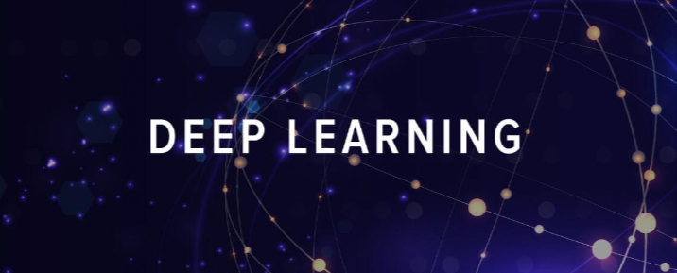
Abstract
This project is about Deep Learning. Firstly, we will see what deep learning is ? Deep learning (DL) is a machine learning method that allows computers to mimic the human brain, usually to complete classification tasks on images or non-visual data sets. Deep learning has recently become an industry defining tool for it’s to advances in GPU technology. Deep learning is a type of machine learning and artificial intelligence (AI) that imitates the way humans gain certain types of knowledge includes predictive modelling. It is used specially to handle huge amount of data. Machine learning can only handle small amount of data. It is used to solve complex problems (real world problems). Deep Learning is used in medical fields, in robotics to identify the things in the surroundings and in self driving cars, translation of language, artificial intelligence programs etc. deep learning is part of a broder family of machine learning methods based on artificial neural networks with representation learning .learning can be supervised, semi-supervised or unsupervised.

History of deep learning

The history of deep learning could be traced back to 1943; Walter Pitts and Warren McCulloch created a computer model based on the neural networks of the human brain. They used a combination of algorithms and mathematics the called “threshold logic” to mimic the thought process.
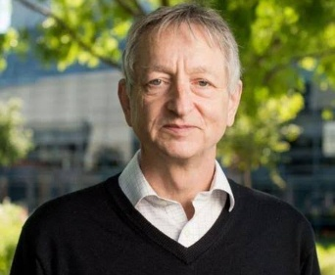
Geoffrey Everest Hinton, Father of deep learning
1.1 Father of Deep Learning
The first serious deep learning breakthrough came in mid-1960s when mathematician Alexey created small but functional neural networks.
Geoffrey Everest Hinton born on 6 dec 1947 is a british-canadian cognitive psychologist and computer scientist, most noted for Google (Google brain) and the university of Toronto. In 2017, he cofounded and became the chief scientific advisor of the vector institute in Toronto. Hinton received the 2018 Turing award, together with Yoshua Bengio and Yann LeCun.

Deep Learning VS Machine Learning
Machine Learning (ML) is an implementation of Artificial Intelligence in which a computer is fed data, and it is supposed to “learn” and make choices based on that data. By doing this, a computer can start making choices without the need to be explicitly programmed to do so. Moreover, the “learning” of the computer can be supervised or unsupervised.
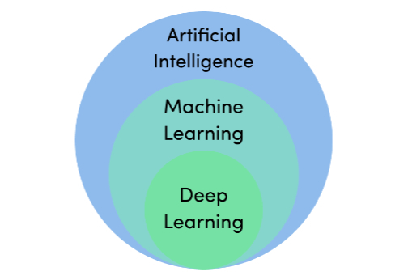
Supervised learning consists of a machine being fed data that is already labelled. This way, the machine learns from the data and a model that instructs it how to react to said training data. Unsupervised learning consists of a machine being fed data that is unlabeled. The machine is left to its own devices to find patterns that may also surprise the person in charge of the machine.
Now that we have machine learning out of the way, let’s draw our attention to the basics of deep learning. In simple words, deep learning is just a mathematically complex version of machine learning.
In comparison to ML models, deep learning models do not require as much supervision and guidance because they are programmed to decide for themselves whether they are making the right choice or not.

